# **TIMETABLE MANAGEMENT – ANALYSIS DOCUMENT**

SEP1 CLASS Y GROUP 6 – DNFC()

Daniel Lopes Adrião, Dragos-Daniel Bonaparte, Laura Rebelo & Matas Armonaitis

17th of November

## Summary

VIA’s timetable manager needs a system to make timetables for students and teachers. The University has a lot of courses, yet a limited number of classrooms. Some rooms can expand their capacity, but only a few.

The process of making a timetable is: 1) importing a file from head of department with information about the current semester, 2) scheduling sessions for every course and 3) making further adjustments regarding students with credits or sessions that have to be cancelled or rescheduled.

The system represents a big step in creating timetables for students and teachers more efficiently and conveniently. A future update might include a login system, which would greatly improve privacy. It could also serve as a backbone for a system that could include a personal user profile including grade transcripts, absence record and possibly even feedback exchange between teachers and students inside the platform.

Table of Contents

Summary 1

Functional Requirements 2

Use case diagram 3

Use case descriptions 4

Relation between requirements and use cases 7

Activity diagrams 8

Domain model 11

# Functional Requirements

**CRITICAL PRIORITY**

1. As a timetable manager, I want to schedule a session so that teachers and students know when to get together for a session.
2. As a timetable manager, I want students and teachers to be assigned to the courses that they learn or teach so that these appear on their timetables.
3. As a timetable manager, I want to book classrooms for sessions so that students and teachers have a place to get together.
4. As a timetable manager, I want to be able to cancel sessions so that there are more classrooms available for other sessions.
5. As a timetable manager, the access to the planning tool should be limited to me so that I am the only one able to modify schedules.
6. As a timetable manager, I want to see which classrooms are available when scheduling a class so that there are no overlaps.
7. As a student or teacher, I want to see my timetable so that I know when and where I have sessions.
8. As a timetable manager, I want to pick how many weekly sessions and the number of lessons per session a course needs given its ECTS count, so that it will be consistent throughout the semester and I can know whether I regularly need to cancel sessions for that course or schedule extra sessions - for the course to have the appropriate number of total lessons.

**HIGH PRIORITY**

1. As a timetable manager, I want to reschedule sessions so that unforeseen events (illness, personal problems, events) do not get in the way of the intended number of lessons for each course.
2. As a timetable manager, I want the changes made to the schedules to be immediately available for students and teachers to see, so that they are always up to date with their timetables.
3. As a timetable manager, I want to remove students from a class so that I can assign them to another class if they have requested a switch.
4. As a timetable manager, I want to add students to a class so that they can have access to a new timetable if they have requested to switch classes.
5. As a timetable manager, I want to be able to assign two teachers to the same course when the course requires it.
6. As a timetable manager, I want to remove students from a course so that it will not appear in their timetable.
7. I want to be able to edit enrollment in a course so that I can add individual students to specific courses.

**LOW PRIORITY**

1. As a timetable manager, I want to be able to double the capacity of a room and merge two classes if it has a foldable wall.
2. -
3. As a user of this system, I want to see my schedule on a weekly format, so that I can see the sessions for each day.
4. As a user of this system, I want to be able to filter only the schedules that include my VIA ID.
5. As a user of this system, I want to be warned when sudden changes appear in the schedules.

**NON-FUNCTIONAL REQUIREMENTS:**

1. As a timetable manager, when assigning a student with credits to a course from another semester, I want the system to check if a timetable without overlaps is available for this student.

# Use case diagram

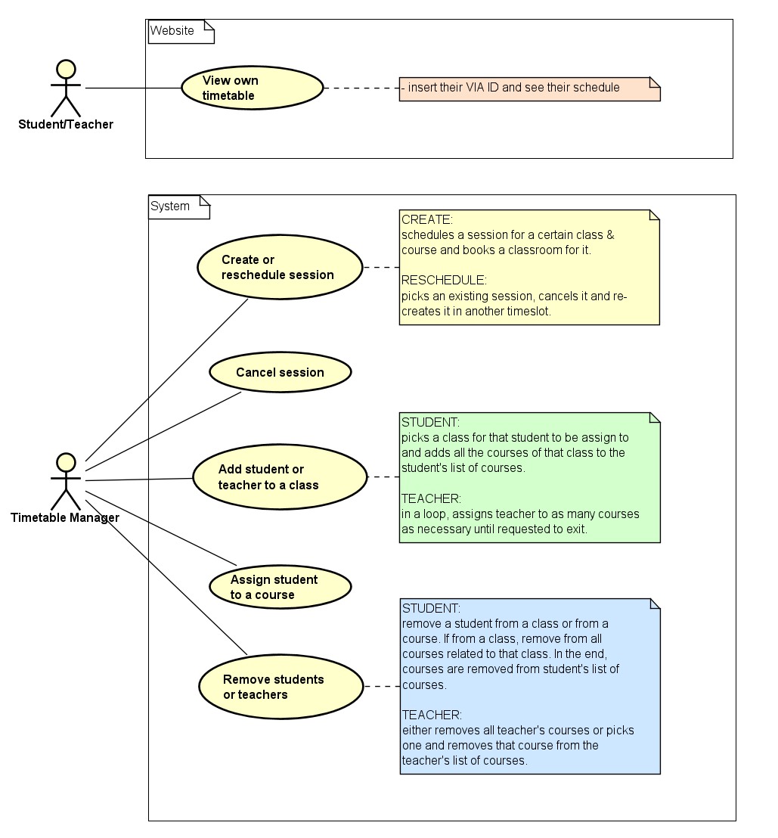

# Use case descriptions

|  |  |
| --- | --- |
| Use case | Create or reschedule session |
| Summary | Create or reschedule a session. |
| Actor | Timetable Manager |
| Precondition | The courses, students and teachers must be registered in the system, given the information from the head of department. The number of lessons a course needs to have given its ECTS count must have been calculated. |
| Postcondition | The timetable is updated for the students and teachers affected by the change. The classroom associated with the session is marked either as booked or available accordingly. |
| Base Sequence | 1. Pick a semester and a class. 2. Pick whether to create or reschedule a session.   IF CREATE, GO TO 3.  IF RESCHEDULE, GO TO 21.   1. Pick if it is a one-time session or recurring session (repeats week after week).   IF ONE-TIME, GO TO 4.  IF PERMANENT, GO TO 7.   1. Pick a week. 2. Show all sessions existing for that class and week. 3. GO TO 9. 4. Display all recurring sessions for that class. 5. GO TO 9. 6. Pick which course they are booking the session for. 7. Display the number of lessons that course needs weekly on average, given its ECTS count. 8. Ask for the length of the session being booked. 9. Display a suggestion for where to put the session given that classes should not have gaps between them. 10. Pick a time slot (day and hour) from the default starting hours for classes in VIA. 11. System checks for validity of the start and end time (no overlaps for both students and teachers, no sooner than 8:20 and no later than 18:00). The overlaps are checked by seeing if the courses associated with that student or teacher have any sessions scheduled for that timeslot. 12. Display which classrooms are available for that timeslot. 13. Pick a classroom. (If first semester, display suggestion. If the regular room is taken and the capacity of both rooms is the same, suggest a swap with the session who is occupying it.) 14. If there are no classrooms available, pick another timeslot. 15. If the room is expandable pick whether the capacity should be increased for that session. 16. The room is booked. 17. END USE CASE.   **RESCHEDULE - one-time or permanent:**   1. Pick whether it is a one-time modification or a permanent one.   IF ONE-TIME, GO TO 22.  IF PERMANENT, GO TO 25.   1. Pick a week. 2. Show all sessions existing for that week. 3. GO TO 27. 4. Display all permanent sessions in a timetable. 5. GO TO 27. 6. Select a session to be rescheduled. 7. Cancel the session selected (and all its weekly repetitions if it is a permanent change). 8. Pick the week in which the new session should be booked. 9. Repeat steps 10 to 20. |
| Exception Sequence | In step 18: If there are no timeslots suitable for everyone associated with that session, book an online session. (No room) |
| Note | After changes have been made, the schedules are updated and whoever accesses the website will see the new changes.  The requirements met by this Use Case are 1, 2, 3, 4, 5, 6, 8, 9, 11 and 13. |

|  |  |
| --- | --- |
| Use case | Cancel sessions |
| Summary | The timetable manager cancels a session. |
| Actor | Timetable Manager |
| Precondition | There are sessions scheduled for the class in question. |
| Postcondition | The session is no longer in the system. |
| Base Sequence | 1. Pick a semester (e.g., 1…7). 2. Pick a class (e.g., x, y, z) 3. Pick a week. 4. Display all sessions from that week. 5. Pick which session is being cancelled. 6. The session is cancelled. 7. END USE CASE. |
| Exception Sequence |  |
| Note | The requirement met by this use case is 4. |

|  |  |
| --- | --- |
| Use case | Add student or teacher to a CLASS |
| Summary | A student or teacher is added to a class. |
| Actor | Timetable manager |
| Precondition | Students and teachers’ VIA IDs are registered in the system. |
| Postcondition | The student or teacher is assigned to every course associated with a class. |
| Base Sequence | 1. Insert VIA ID.   IF VIA ID IS STUDENT, GO TO 2.  IF VIA ID IS TEACHER, GO TO 6.   1. Pick a semester. 2. Pick a class. 3. Assign all the courses for that class to that student. 4. END USE CASE. 5. Pick a semester. 6. Pick a class. 7. Pick a course. 8. Assign teacher to that course and class. 9. Repeat until requested to exit. 10. END USE CASE. |
| Exception Sequence |  |
| Note | This use case might be useful when a student enrolls after the semester has already started, if a student changes class or for when a teacher is assigned to a new class.  The requirements met for this use case are: 12 and 21. |

|  |  |
| --- | --- |
| Use case | Assign student to course |
| Summary | A student is assigned to a specific course. |
| Actor | Timetable manager |
| Precondition | Students’ VIA IDs and existing courses are registered in the system. The student is already part of a class and has their own timetable. |
| Postcondition | The course is added to the student’s list of courses. |
| Base Sequence | 1. Insert student’s VIA ID. 2. Pick a semester. 3. Pick a course. 4. SYSTEM - Check if there is a timetable without overlaps available for this student. 5. With this information, pick a class (e.g., X, Y, Z…). 6. Add course to student’s list of courses. 7. END USE CASE. |
| Exception Sequence |  |
| Note | This use case might be useful for when a student with credits wants to be enrolled in a class from another semester, or to manage exchange students.  The requirements met for this use case are 15 and 20. |

|  |  |
| --- | --- |
| Use case | Remove students or teachers |
| Summary | Remove students and teachers from a course, class or from university. |
| Actor | Timetable Manager |
| Precondition | The students and teachers need to have VIA IDs and to have been previously assigned to courses. |
| Postcondition | The students or teachers are removed from a course, from all the courses associated to a class or entirely removed from the system. |
| Base Sequence | 1. Input VIA ID.   IF VIA ID IS **STUDENT**, GO TO 2.  IF VIA ID IS **TEACHER**, GO TO 11.   1. Ask if it is removing from a class, or from just a specific course.   IF **CLASS**, GO TO 3.  IF **COURSE**, GO TO 6.   1. Ask: “Are you sure you want to remove this student from his class?” 2. If yes, remove student from all the courses associated with that class. 3. END USE CASE. 4. Pick a course. 5. Display: “Are you sure you want to remove student XXX from course ABC?” 6. If yes, student is removed from that course. 7. If no, go back to 6. 8. END USE CASE. 9. Ask if remove teacher completely or just from one course.   IF REMOVED COMPLETELY, GO TO 12.  IF JUST ONE COURSE, GO TO 14.   1. Remove teacher from all associated courses & classes. 2. END USE CASE. 3. Show all current courses for this teacher. 4. Pick one. 5. Remove teacher from that course. 6. END USE CASE. |
| Exception Sequence |  |
| Note | The requirement met by this use case are 11 and 19. |

|  |  |
| --- | --- |
| Use case | View own timetable |
| Summary | The students and teachers get access to their timetables through the website. |
| Actor | Student, Teacher |
| Precondition | A time schedule has been previously created for the user by the timetable manager. |
| Postcondition | The student/teacher has knowledge of their timetable. |
| Base Sequence | 1. Go to the website.  2. Go to the schedule page.  3. Insert VIA ID.  4. All the courses with that ID are fetched and displayed in a weekly format for the user to see.  5. If any changes have been made recently to any sessions, display a warning message. |
| Exception Sequence |  |
| Note | The requirements met by this use case are 7, 10, 16, 17 and 18. |

# Relation between requirements and use cases

|  |  |
| --- | --- |
| Use cases | Covered requirements |
| Create or reschedule sessions | 1, 2, 3, 4, 5, 6, 8, 9, 11, 13 |
| Cancel sessions | 4 |
| Add student or teacher to a class | 12, 21 |
| Assign student to course | 15, 20 |
| Remove student or teacher | 11, 19 |
| View own timetable | 7, 10, 16, 17, 18 |

# 

# Activity diagrams

Create or reschedule session

Cancel session

Add student or teacher to class

Assign student to course

Remove student or teacher

View timetable

# Domain model

